Invitation to complete a criminal record check – Access Personal Checking Service (APCS)

Dear

Thank you for your application to work with children and / or adults at risk. In order to
complete your online version of the Disclosure & Barring Service application form please click on the following link https://www.onlinedbscheck.co.uk/login.aspx?returnurl=%2f which will take you to the screen shown below.
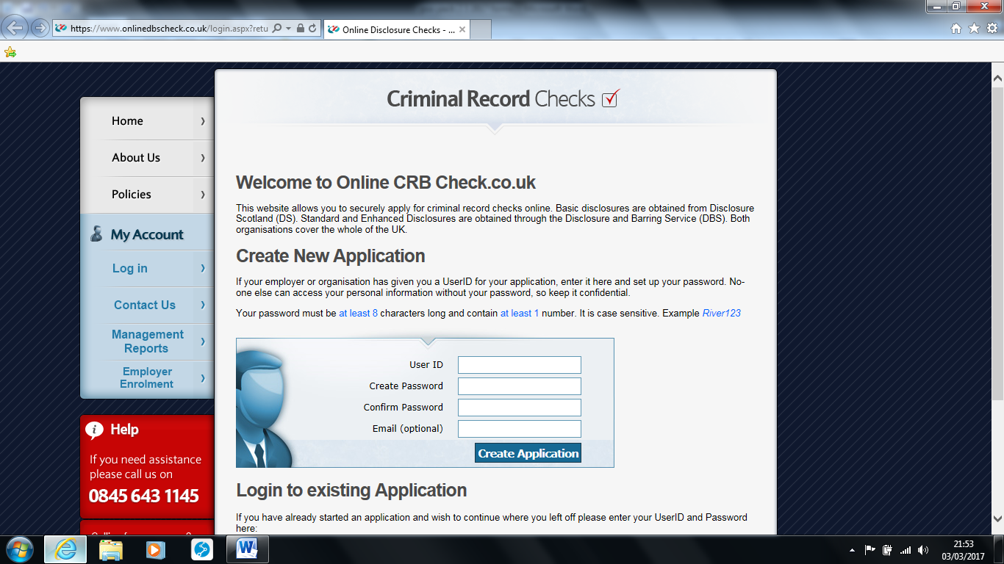

You will be asked to provide your User ID number - which is Parish ID Checker to insert
You will be asked to create a password and to enter your e-mail address
Then click Create Account.
NB please do not click anywhere else on this screen as it may take you away from the form you are required to complete.

Don’t forget that once you have completed your form online you will need to show me your
identification documents. A list of documents you can use is attached. Please ensure that you also give me your completed Confidential Declaration Form and Personal Details Form

If you need any further assistance, please feel free to contact me as your parish’s identity
verifier

