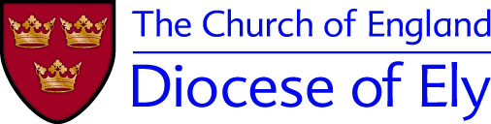
Overseas/Overnight/Residential trips: Supplementary Permission Form

This is a supplementary form to be used in addition to the general permission form, whenever activities will involve one or more nights away OR a trip overseas (eg a day trip outside the UK)

Insurance Advice
If the trip involves travelling in a non-UK country, parents are asked to provide their own travel insurance for the child. This should include cover for medical expenses, loss of baggage, cancellation etc. See the trip leader for further advice.

Title of trip:

Date of trip:

Surname of child Forename(s)

Address: Date of birth

Child’s mobile phone no. (if applicable)

Are there any allergies, medical conditions and/or prescribed medicines we should be aware of? Please use a separate sheet if necessary.

Special dietary needs? Please provide clear details, using a separate sheet if necessary.
If inoculations are required for this trip, please confirm that these have been done, with inoculations given and dates.
Are you happy for pictures and video clips to be taken by leaders of the trip, which may include your child, for use within the group and the church? (NB leaders will follow picture and image safety guidelines relating to taking, storing and sharing pictures; these are available from the trip leader or the Diocesan website).
YES NO (please circle the answer that applies)

Emergency Contact in UK

Name

Relationship to child

Address

Contact telephone number Mobile/e mail

Alternative contact:

Name

Relationship to child
Address
Contact telephone number Mobile/e mail

For trips outside the UK:

Passport Number Place of issue

Date of expiry Nationality

Please read and sign
I have read the information which has been supplied about this visit and I give permission for my child to take part.

Signed……………………………………………… Date……………

